**CRF 113843: CRF for RM, RHA, AM SECURITY, AH and Internal Auditor Shortage and Surplus Report**

RM, RHA, AM SECURITY, AH and Internal Auditor Shortage and Surplus Report of previous day.

Below are queries for getting the 5 reports.

RM Report

select t.region,

t.fzm FZM,

t.staffnorms Norms,

t.live_punch,

t.less_10days,

t.undernoticeperiod UNP,

t.shortage10days,

t.surplus Surplus,

t.actualshortage Shortage

from tableau_punch_shortdata_new t

where trunc(PR_DATE) = (case

when trunc(sysdate, 'd') + 1 = trunc(sysdate) then

trunc(sysdate) - 2

else

trunc(sysdate) - 1

end)

and post = 'REGIONAL MANAGER'

and (t.actualshortage >= 1 or t.surplus >= 1)

RHA Report

select t.region,

t.fzm FZM,

t.staffnorms Norms,

t.live_punch,

t.less_10days,

t.undernoticeperiod UNP,

t.shortage10days,

t.surplus Surplus,

t.actualshortage Shortage

from tableau_punch_shortdata_new t

where trunc(PR_DATE) = (case

when trunc(sysdate, 'd') + 1 = trunc(sysdate) then

trunc(sysdate) - 2

else

trunc(sysdate) - 1

end)

and post = 'REGIONAL HEAD (AUDIT)'

and (t.actualshortage >= 1 or t.surplus >= 1)

ARM/AM-Security Report

select t.region,

t.fzm FZM,

t.staffnorms Norms,

t.live_punch,

t.less_10days,

t.undernoticeperiod UNP,

t.shortage10days,

t.surplus Surplus,

t.actualshortage Shortage

from tableau_punch_shortdata_new t

where trunc(PR_DATE) = (case

when trunc(sysdate, 'd') + 1 = trunc(sysdate) then

trunc(sysdate) - 2

else

trunc(sysdate) - 1

end)

and post = 'ARM/AM-SECURITY'

and (t.actualshortage >= 1 or t.surplus >= 1)

AH Report

select t.area,

t.region,

t.fzm,

t.staffnorms Norms,

t.live_punch,

t.less_10days,

t.undernoticeperiod UNP,

t.shortage10days,

t.surplus Surplus,

t.actualshortage Shortage

from tableau_punch_shortdata_new t

where trunc(PR_DATE) = (case

when trunc(sysdate, 'd') + 1 = trunc(sysdate) then

trunc(sysdate) - 2

else

trunc(sysdate) - 1

end)

and post = 'AREA HEAD'

and (t.actualshortage >= 1 or t.surplus >= 1)

Internal Auditor

select t.region,

t.fzm FZM,

t.staffnorms Norms,

t.live_punch,

t.less_10days,

t.undernoticeperiod UNP,

t.shortage10days,

t.surplus Surplus,

t.actualshortage Shortage

from tableau_punch_shortdata_new t

where trunc(PR_DATE) = (case

when trunc(sysdate, 'd') + 1 = trunc(sysdate) then

trunc(sysdate) - 2

else

trunc(sysdate) - 1

end)

and post = 'INTERNAL AUDITOR'

and (t.actualshortage >= 1 or t.surplus >= 1)

* Send mail on daily basis.

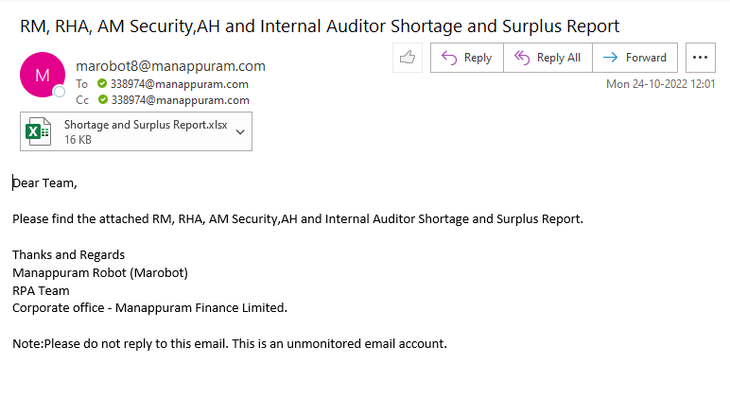

* Mail needs to send t below mail id’s

To: [hrteam@manappuram.com](mailto:hrteam@manappuram.com)

Cc: [joshy@manappuram.com](mailto:joshy@manappuram.com), [hr.sragm@manappuram.com](mailto:hr.sragm@manappuram.com), [pshead@manappuram.com](mailto:pshead@manappuram.com), [agmsales@manappuram.com](mailto:agmsales@manappuram.com), [smhr@manappuram.com](mailto:smhr@manappuram.com)